**PROJECT : COVID QUARANTINE CENTRE MANAGEMENT SYSTEM**

**THIS DOCUMENT CONTAINS CODES OF ALL INDIVIDUAL FILES ALONG WITH THEIR EXECUTION OUTPUT ONE BY ONE.**

**Code for Login.java**

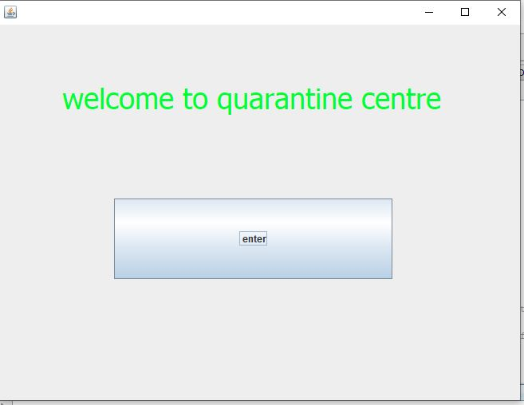

package newpackage;

import java.sql.*;

import javax.swing.*;

public class Login extends javax.swing.JFrame {

/** Creates new form Login */

public Login() {

initComponents();

}

private void jButton1ActionPerformed(java.awt.event.ActionEvent evt) {

FirstPage p=new FirstPage();

p.setVisible(true);

this.dispose();

}

**Code for Second.java**

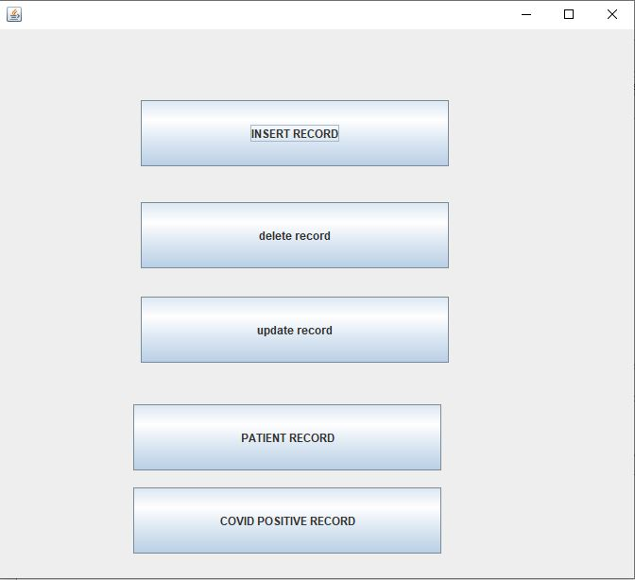

package newpackage;

public class SECOND extends javax.swing.JFrame {

public SECOND() {

initComponents();

}

private void jButton7ActionPerformed(java.awt.event.ActionEvent evt) {

Delete d1= new Delete();

d1.setVisible(true);

this.dispose();

}

private void jButton8ActionPerformed(java.awt.event.ActionEvent evt) {

Update u1= new Update();

u1.setVisible(true);

this.dispose();

}

private void jButton9ActionPerformed(java.awt.event.ActionEvent evt) {

FirstPage p1 = new FirstPage();

p1.setVisible(true);

this.dispose();

}

private void jButton10ActionPerformed(java.awt.event.ActionEvent evt) {

Show_patientTable g1= new Show_patientTable();

g1.setVisible(true);

this.dispose();

}

private void jButton11ActionPerformed(java.awt.event.ActionEvent evt) {

Show_covidpos_Table c1= new Show_covidpos_Table();

c1.setVisible(true);

this.dispose();

}

**Code for FirstPage.java**

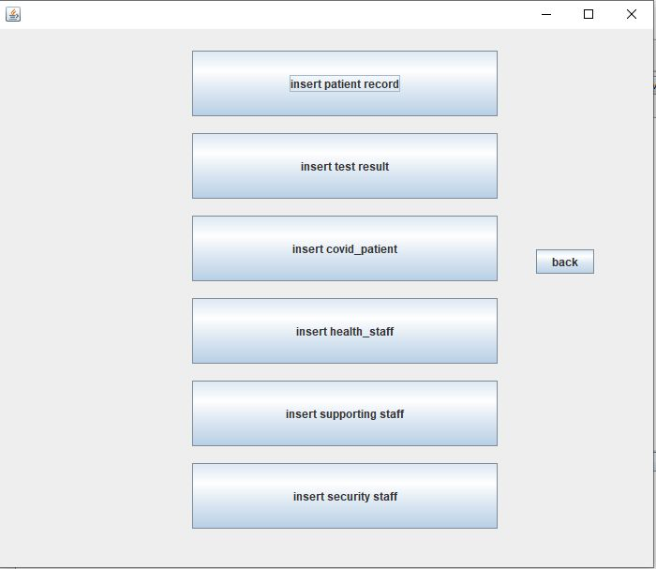

package newpackage;

public FirstPage() {

initComponents();

}

private void jButton1ActionPerformed(java.awt.event.ActionEvent evt) {

Patient n=new Patient();

n.setVisible(true);

this.dispose();

}

private void jButton2ActionPerformed(java.awt.event.ActionEvent evt) {

Test nj2= new Test();

nj2.setVisible(true);

this.dispose();

}

private void jButton3ActionPerformed(java.awt.event.ActionEvent evt) {

CovidPos nj3= new CovidPos();

nj3.setVisible(true);

this.dispose();

}

private void jButton4ActionPerformed(java.awt.event.ActionEvent evt) {

Health_Staff nj4= new Health_Staff();

nj4.setVisible(true);

this.dispose();

}

private void jButton5ActionPerformed(java.awt.event.ActionEvent evt) {

Supporting_Staff nj5= new Supporting_Staff();

nj5.setVisible(true);

this.dispose();

}

private void jButton6ActionPerformed(java.awt.event.ActionEvent evt) {

Security_staff nj6= new Security_staff();

nj6.setVisible(true);

this.dispose();

}

private void jButton7ActionPerformed(java.awt.event.ActionEvent evt) {

SECOND s1= new SECOND();

s1.setVisible(true);

this.dispose();

}

**Code for Patient.java**

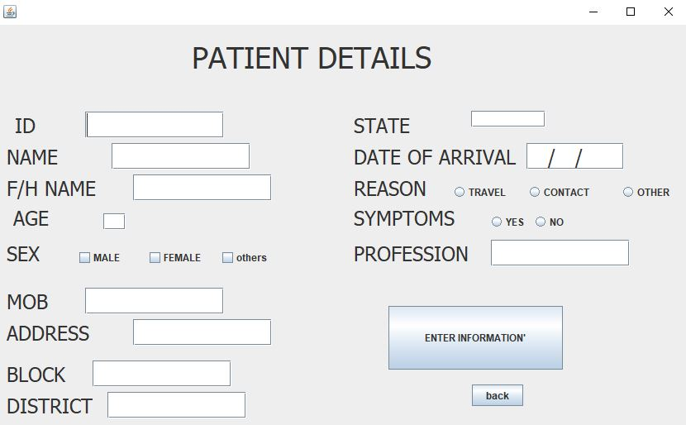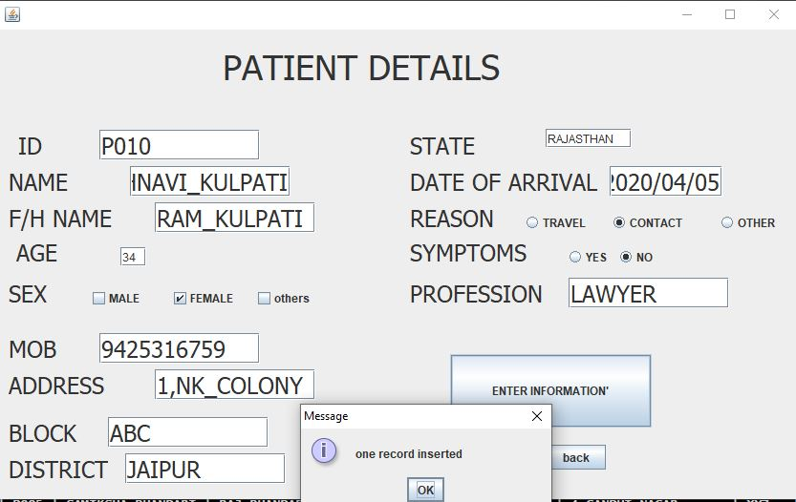

package newpackage;

import java.sql.*;

import java.sql.DriverManager;

import javax.sql.*;

import javax.swing.*;

public class Patient extends javax.swing.JFrame {

public Patient() {

initComponents();

}

private void jButton1ActionPerformed(java.awt.event.ActionEvent evt) {

String id=(String)jTextField1.getText();

String name=(String)jTextField2.getText();

String f_name=(String)jTextField3.getText();

String mob=(String)jTextField4.getText();

String address=(String)jTextField5.getText();

String block =(String)jTextField6.getText();

String district =(String)jTextField7.getText();

String doa =(String)jTextField8.getText();

String prof =(String)jTextField9.getText();

int age=Integer.parseInt(jTextField10.getText());

String rea="";

if(jRadioButton1.isSelected()) {

rea="travel";

}

if(jRadioButton2.isSelected()) {

rea="contact";

}

if(jRadioButton3.isSelected()) {

rea="others";

}

String sex="";

if(jCheckBox1.isSelected()) {

sex="male";

}

if(jCheckBox2.isSelected()) {

sex="female";

}

if(jCheckBox3.isSelected()) {

sex="OTHERS";

}

String sym="";

if(jRadioButton4.isSelected()) {

sym="yes";

}

if(jRadioButton5.isSelected()) {

sym="no";

}

String state=(String)jTextField11.getText();

try {

Class.forName("java.sql.DriverManager");

Connection c=DriverManager.getConnection("jdbc:mysql://localhost/shruti","root","123");

Statement s=c.createStatement();

String query;

query="insert into patient values('"+id+"','"+name+"','"+f_name+"',"+age+",'"+sex+"','"+mob+"','"+address+"','"+block+"','"+district+"','"+state+"','"+doa+"','"+rea+"','"+sym+"','"+prof+"');";

s.executeUpdate(query);

JOptionPane.showMessageDialog(null,"one record inserted");

FirstPage p=new FirstPage();

p.setVisible(true);

this.dispose();

} catch (Exception e) { JOptionPane.showMessageDialog(null,e.getMessage());

}

}

private void jButton2ActionPerformed(java.awt.event.ActionEvent evt) {

FirstPage p=new FirstPage();

p.setVisible(true);

this.dispose();

}

**Code for Test.java**

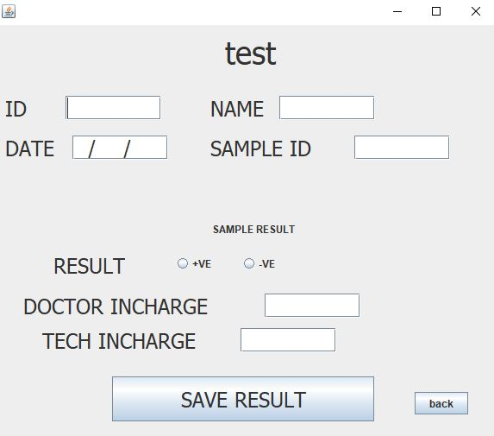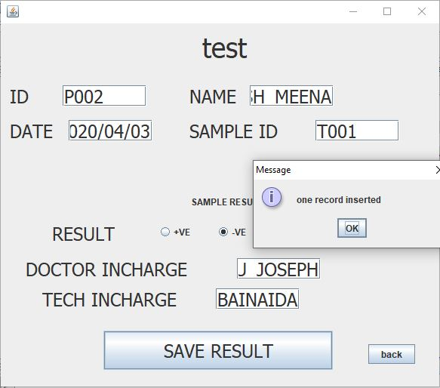

package newpackage;

import java.sql.*;

import javax.sql.*;

import javax.swing.*;

public class Test extends javax.swing.JFrame {

public Test() {

initComponents();

}

private void jButton1ActionPerformed(java.awt.event.ActionEvent evt) {

String id=(String)jTextField1.getText();

String date=(String)jTextField2.getText();

String sampleid=(String)jTextField3.getText();

String name=(String)jTextField4.getText();

String res = "";

if(jRadioButton3.isSelected())

{

res="positive";

}

else if(jRadioButton4.isSelected())

{

res="negative";

}

String doctor=(String)jTextField7.getText();

String tech=(String)jTextField8.getText();

try {

Class.forName("java.sql.DriverManager");

Connection c=DriverManager.getConnection("jdbc:mysql://localhost/shruti","root","123");

Statement s=c.createStatement();

String query;

query= " insert into test values( '"+id+"','"+name+"','"+date+"' ,'"+sampleid+"','"+doctor+"','"+tech+"','"+res+"');";

s.executeUpdate(query);

JOptionPane.showMessageDialog(null, "one record inserted");

FirstPage p=new FirstPage();

if (jRadioButton3.isSelected())

{

CovidPos nj3= new CovidPos();

nj3.setVisible(true);

this.dispose();

}

p.setVisible(true);

this.dispose();

} catch (Exception e) {

JOptionPane.showMessageDialog(null,e.getMessage());

}

}

private void jButton4ActionPerformed(java.awt.event.ActionEvent evt) {

FirstPage p=new FirstPage();

p.setVisible(true);

this.dispose();

}

Code for covid

package newpackage;

import java.sql.*;

import javax.sql.*;

import javax.swing.*;

import javax.swing.JOptionPane;

public class CovidPos extends javax.swing.JFrame {

public CovidPos() {

initComponents();

}

private void jButton1ActionPerformed(java.awt.event.ActionEvent evt) {

String id=(String)jTextField1.getText();

String name=(String)jTextField4.getText();

String hospital=(String)jTextField2.getText();

String date=(String)jTextField3.getText();

try {

Class.forName("java.sql.DriverManager");

Connection c=DriverManager.getConnection("jdbc:mysql://localhost/shruti","root","123");

Statement s=c.createStatement();

String query;

query="insert into covid_pos values( '"+id+"','"+name+"','"+hospital+"','"+date+"');";

s.executeUpdate(query);

JOptionPane.showMessageDialog(null, "one record inserted");

FirstPage p=new FirstPage();

p.setVisible(true);

this.dispose();

} catch (Exception e) {JOptionPane.showMessageDialog(null, e.getMessage());

}

}

private void jButton2ActionPerformed(java.awt.event.ActionEvent evt) {

FirstPage p=new FirstPage();

p.setVisible(true);

this.dispose();

}

**Code for Health_Staff.java**

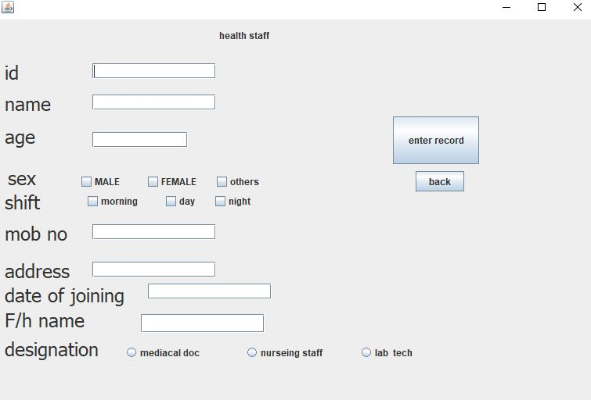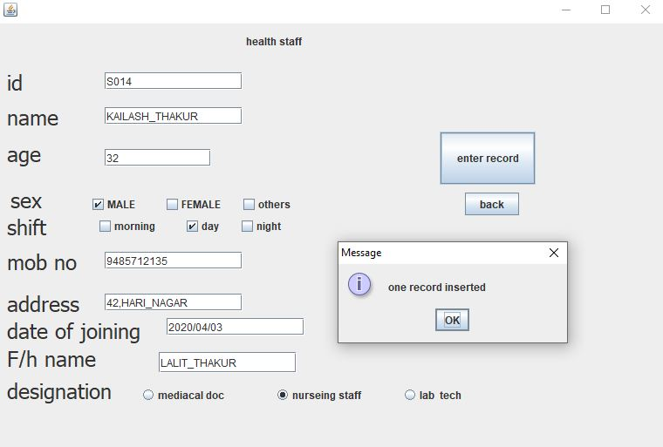

package newpackage;

import java.sql.*;

import javax.sql.*;

import javax.swing.*;

import javax.swing.JOptionPane;

public class Health_Staff extends javax.swing.JFrame {

public Health_Staff() {

initComponents();

}

private void jButton1ActionPerformed(java.awt.event.ActionEvent evt) {

String id=(String)jTextField1.getText();

String name=(String)jTextField2.getText();

String mob=(String)jTextField6.getText();

String address=(String)jTextField7.getText();

String date=(String)jTextField8.getText();

String f_name=(String)jTextField9.getText();

int age=Integer.parseInt(jTextField3.getText());

String sex="";

if(jCheckBox1.isSelected())

{

sex="male";

}

if(jCheckBox2.isSelected())

{

sex="female";

}

if(jCheckBox3.isSelected())

{

sex="others";

}

String shift="";

if(jCheckBox4.isSelected())

{

shift="morning";

}

if(jCheckBox5.isSelected())

{

shift="day";

}

if(jCheckBox6.isSelected())

{

shift="night";

}

String des="";

if(jRadioButton1.isSelected())

{

des="medical_officer";

}

if(jRadioButton2.isSelected())

{

des="nurseing_officer";

}

if(jRadioButton3.isSelected())

{

des="lab_tech";

}

try { Class.forName("java.sql.DriverManager");

Connection c=DriverManager.getConnection("jdbc:mysql://localhost/shruti","root","123");

Statement s=c.createStatement();

String query;

query="insert into health_professionals values('"+id+"','"+name+"','"+f_name+"',"+age+",'"+sex+"','"+shift+"','"+mob+"','"+address+"','"+date+"','"+des+"');";

s.executeUpdate(query);

JOptionPane.showMessageDialog(null,"one record inserted ");

FirstPage p=new FirstPage();

p.setVisible(true);

this.dispose();

} catch (Exception e) { JOptionPane.showMessageDialog(null,e.getMessage());

}

}

private void jButton2ActionPerformed(java.awt.event.ActionEvent evt) {

FirstPage p=new FirstPage();

p.setVisible(true);

this.dispose();

}

**Code for Supporting_Staff.java**

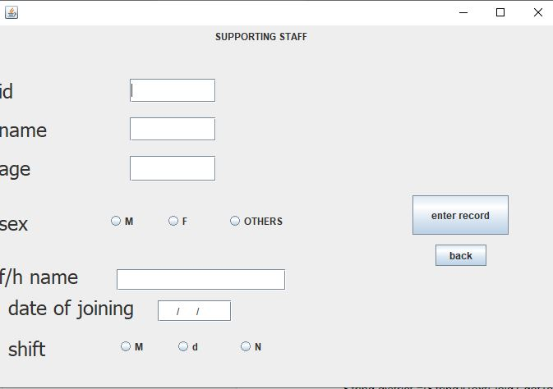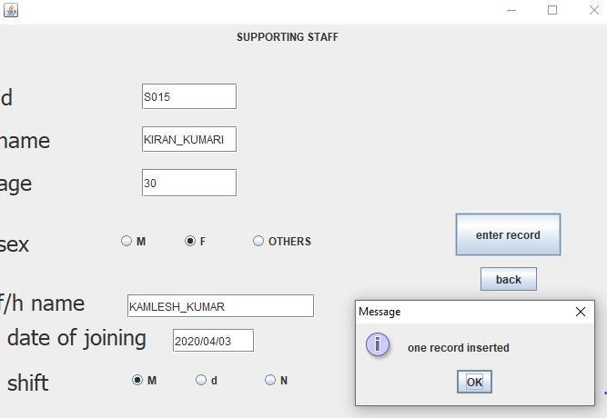

package newpackage;

import java.sql.*;

import javax.sql.*;

import javax.swing.*;

import javax.swing.JOptionPane;

public class Supporting_Staff extends javax.swing.JFrame {

public Supporting_Staff() {

initComponents();

}

private void jTextField6ActionPerformed(java.awt.event.ActionEvent evt) {

}

private void jButton1ActionPerformed(java.awt.event.ActionEvent evt) {

String id=(String)jTextField1.getText();

String name=(String)jTextField2.getText();

String date=(String)jTextField6.getText();

String f_name=(String)jTextField5.getText();

int age=Integer.parseInt(jTextField3.getText());

String sex="";

if(jRadioButton1.isSelected())

{

sex="male";

}

if(jRadioButton2.isSelected())

{

sex="female";

}

if(jRadioButton3.isSelected())

{

sex="others";

}

String shift="";

if(jRadioButton4.isSelected())

{

shift="morning";

}

if(jRadioButton5.isSelected())

{

shift="day";

}

if(jRadioButton6.isSelected())

{

shift="night";

}

try { Class.forName("java.sql.DriverManager");

Connection c=DriverManager.getConnection("jdbc:mysql://localhost/shruti","root","123");

Statement s=c.createStatement();

String query;

query="insert into supporting_staff values('"+id+"','"+name+"','"+f_name+"',"+age+",'"+sex+"','"+shift+"','"+date+"');";

s.executeUpdate(query);

JOptionPane.showMessageDialog(null,"one record inserted ");

FirstPage p=new FirstPage();

p.setVisible(true);

this.dispose();

} catch (Exception e) { JOptionPane.showMessageDialog(null,e.getMessage());

}

}

private void jButton2ActionPerformed(java.awt.event.ActionEvent evt) {

FirstPage p=new FirstPage();

p.setVisible(true);

this.dispose();

}

**Code for Security_staff.java**

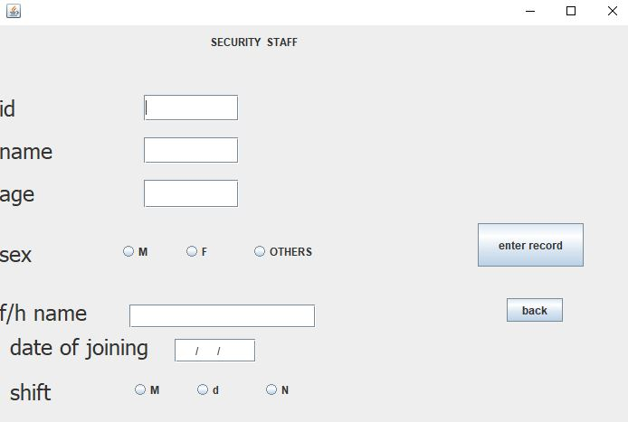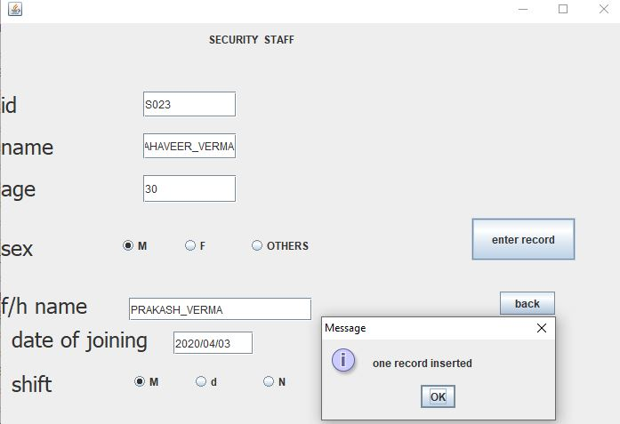

package newpackage;

import java.sql.*;

import javax.sql.*;

import javax.swing.*;

import javax.swing.JOptionPane;

public class Security_staff extends javax.swing.JFrame {

public Security_staff() {

initComponents();

}

private void jButton1ActionPerformed(java.awt.event.ActionEvent evt) {

String id=(String)jTextField1.getText();

String name=(String)jTextField2.getText();

String date=(String)jTextField6.getText();

String f_name=(String)jTextField5.getText();

int age=Integer.parseInt(jTextField3.getText());

String sex="";

if(jRadioButton1.isSelected()) {

sex="male";

}

if(jRadioButton2.isSelected()) {

sex="female";

}

if(jRadioButton3.isSelected()) {

sex="others";

}

String shift="";

if(jRadioButton4.isSelected()) {

shift="morning";

}

if(jRadioButton5.isSelected()) {

shift="day";

}

if(jRadioButton6.isSelected()) {

shift="night";

}

try { Class.forName("java.sql.DriverManager");

Connection c=DriverManager.getConnection("jdbc:mysql://localhost/shruti","root","123");

Statement s=c.createStatement();

String query;

query="insert into security_staff values('"+id+"','"+name+"','"+f_name+"',"+age+",'"+sex+"','"+shift+"','"+date+"');";

s.executeUpdate(query);

JOptionPane.showMessageDialog(null,"one record inserted ");

FirstPage p=new FirstPage();

p.setVisible(true);

this.dispose();

} catch (Exception e) { JOptionPane.showMessageDialog(null,e.getMessage());

}

}

private void jTextField6ActionPerformed(java.awt.event.ActionEvent evt) {

}

private void jButton2ActionPerformed(java.awt.event.ActionEvent evt) {

FirstPage p=new FirstPage();

p.setVisible(true);

this.dispose();

}

**Code for Delete.java**

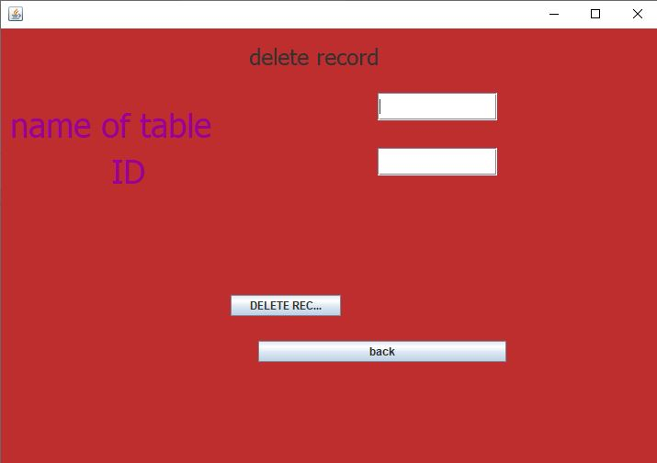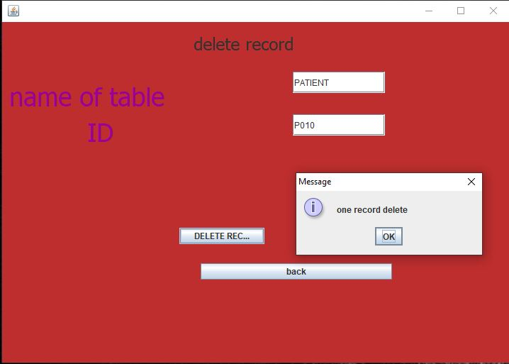

package newpackage;

import java.sql.*;

import javax.swing.*;

public class Delete extends javax.swing.JFrame {

public Delete() {

initComponents();

}

private void jButton1ActionPerformed(java.awt.event.ActionEvent evt) {

String table=(String)jTextField1.getText();

String id=(String)jTextField2.getText();

try {

Class.forName("java.sql.DriverManager");

Connection c=DriverManager.getConnection("jdbc:mysql://localhost/shruti","root","123");

Statement s=c.createStatement();

String query;

query=" delete from "+table+" where id='"+id+"' ;";

s.executeUpdate(query);

JOptionPane.showMessageDialog(null,"one record delete");

} catch (Exception e) { JOptionPane.showMessageDialog(null,e.getMessage());

}

}

private void jButton2ActionPerformed(java.awt.event.ActionEvent evt) {

FirstPage p=new FirstPage();

p.setVisible(true);

this.dispose();

}

**Code for Update.java**

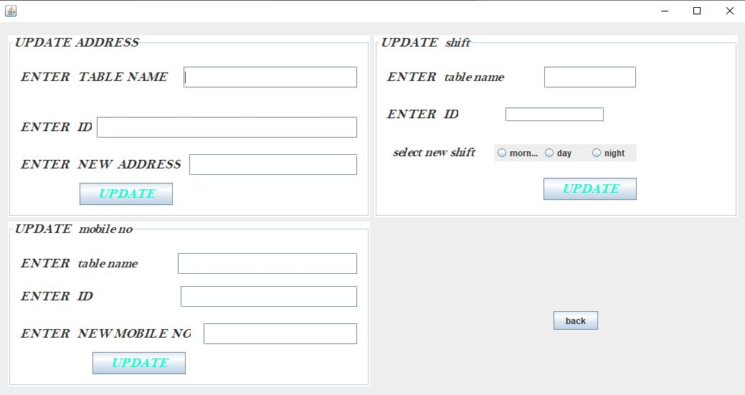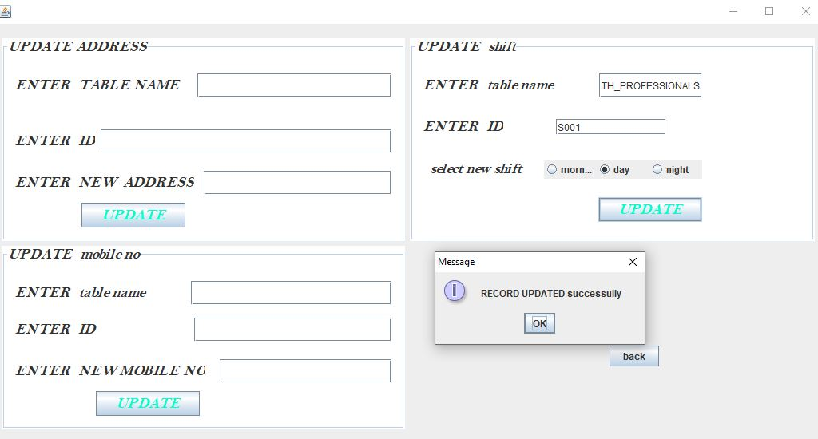

package newpackage;

import java.sql.*;

import javax.swing.*;

public class Update extends javax.swing.JFrame {

public Update() {

initComponents();

}

private void jButton1ActionPerformed(java.awt.event.ActionEvent evt) {

String table_name=(String)jTextField1.getText();

String id=(String)jTextField2.getText();

String new_address=(String)jTextField5.getText();

try {

Class.forName("java.sql.DriverManager");

Connection c=DriverManager.getConnection("jdbc:mysql://localhost/shruti","root","123");

Statement s=c.createStatement();

String query;

query=" Update "+table_name+" set address='"+new_address+"'where id='"+id+"'; ";

s.executeUpdate(query);

JOptionPane.showMessageDialog(null,"RECORD UPDATED successully");

} catch (Exception e) {

JOptionPane.showMessageDialog(null, e.getMessage());

}

}

private void jButton3ActionPerformed(java.awt.event.ActionEvent evt) {

String table =(String)jTextField8.getText();

String mobile_no=(String)jTextField9.getText();

String id=(String)jTextField10.getText();

try {

Class.forName("java.sql.DriverManager");

Connection c=DriverManager.getConnection("jdbc:mysql://localhost/shruti","root","123");

Statement s=c.createStatement();

String query;

query=" update "+table+" set mob_no ='"+mobile_no+"' where id ='"+id+"'; ";

s.executeUpdate(query);

JOptionPane.showMessageDialog(null,"RECORD UPDATED successully");

} catch (Exception e) {

JOptionPane.showMessageDialog(null, e.getMessage());

}

}

private void jButton2ActionPerformed(java.awt.event.ActionEvent evt) {

String table_name =(String)jTextField4.getText();

String id=(String)jTextField3.getText();

String new_shift="";

if(jRadioButton4.isSelected())

{

new_shift="morning";

}

if(jRadioButton5.isSelected())

{

new_shift="day";

}

if(jRadioButton6.isSelected())

{

new_shift="night";

}

try {

Class.forName("java.sql.DriverManager");

Connection c=DriverManager.getConnection("jdbc:mysql://localhost/shruti","root","123");

Statement s=c.createStatement();

String query;

query=" update "+table_name+" set shift ='"+new_shift+"' where id='"+id+"'; ";

s.executeUpdate(query);

JOptionPane.showMessageDialog(null,"RECORD UPDATED successully");

} catch (Exception e) {

JOptionPane.showMessageDialog(null, e.getMessage());

}

}

private void jButton4ActionPerformed(java.awt.event.ActionEvent evt) {

FirstPage p=new FirstPage();

p.setVisible(true);

this.dispose();

}

**Code for Show_patientTable.java**

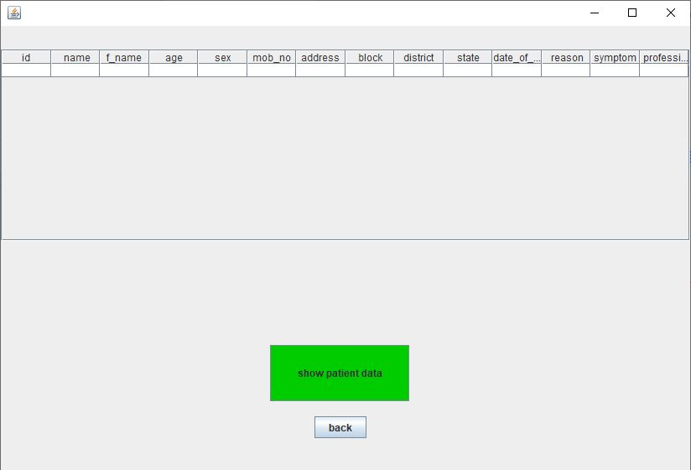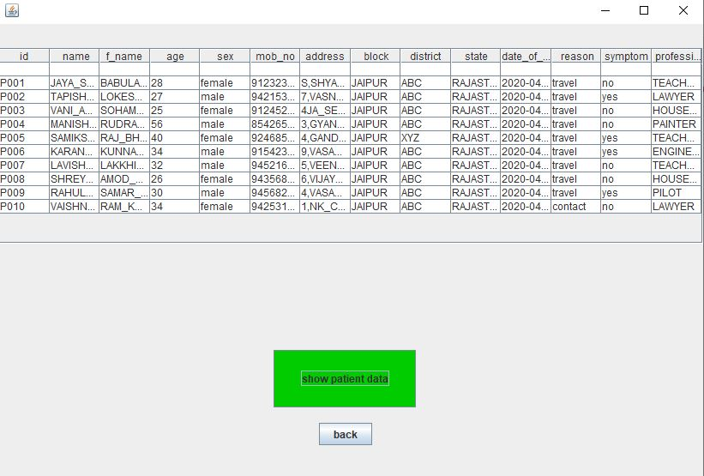

package newpackage;

import java.sql.*;

import javax.swing.*;

import javax.swing.table.DefaultTableModel;

public class Show_patientTable extends javax.swing.JFrame {

public Show_patientTable() {

initComponents();

}

private void jButton1ActionPerformed(java.awt.event.ActionEvent evt) {

String id;

String name;

String f_name;

int age;

String sex;

String mob;

String address;

String district;

String block;

String state;

String date_of_arrival;

String reason;

String symptom;

String profession;

DefaultTableModel d= (DefaultTableModel)jTable1.getModel();

try {

Class.forName("java.sql.DriverManager");

Connection c=DriverManager.getConnection("jdbc:mysql://localhost/shruti","root","123");

Statement s=c.createStatement();

String query;

query="select * from patient;";

ResultSet rs =s.executeQuery(query);

if(rs.next())

{

do

{

id=rs.getString(1);

name=rs.getString(2);

f_name=rs.getString(3);

age =rs.getInt(4);

sex=rs.getString(5);

mob=rs.getString(6);

address=rs.getString(7);

block=rs.getString(8);

district=rs.getString(9);

state=rs.getString(10);

date_of_arrival=rs.getString(11);

reason=rs.getString(12);

symptom=rs.getString(13);

profession=rs.getString(14);

Object a[]={id,name,f_name,age,sex,mob,address,district,block,state,date_of_arrival,reason,symptom,profession};

d.addRow(a);

}while(rs.next());

}

else{

JOptionPane.showMessageDialog(null, "table is empty");

}

c.close();

rs.close();

s.close();

} catch (Exception e) { JOptionPane.showMessageDialog(null, e.getMessage());

}

}

private void jButton2ActionPerformed(java.awt.event.ActionEvent evt) {

SECOND s1= new SECOND();

s1.setVisible(true);

this.dispose();

}

**Code for Show_covidpos_Table.java**

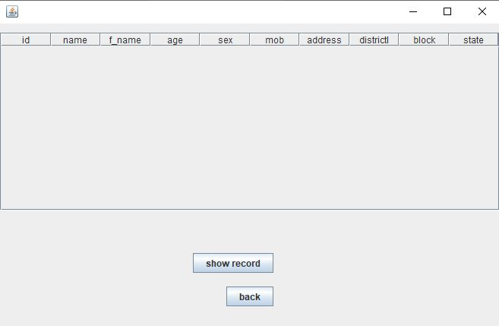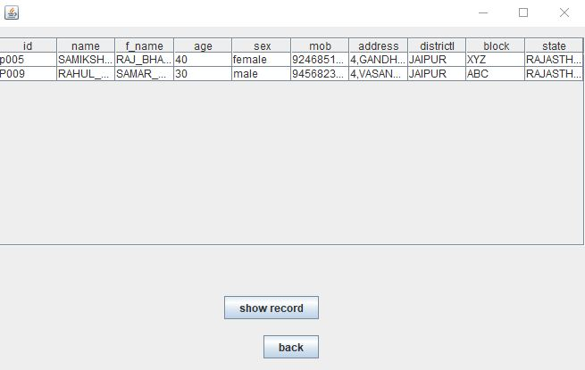

package newpackage;

import java.sql.*;

import javax.swing.*;

import javax.swing.table.DefaultTableModel;

public class Show_covidpos_Table extends javax.swing.JFrame {

public Show_covidpos_Table() {

initComponents();

}

private void jButton1ActionPerformed(java.awt.event.ActionEvent evt) {

String id;

String name;

String f_name;

int age;

String sex;

String mob;

String address;

String district;

String block;

String state;

DefaultTableModel d= (DefaultTableModel)jTable1.getModel();

try {

Class.forName("java.sql.DriverManager");

Connection c=DriverManager.getConnection("jdbc:mysql://localhost/shruti","root","123");

Statement s=c.createStatement();

String query;

query="select covid_pos.id ,patient.name,f_name,age,sex,mob_no,address,district,block,state from covid_pos,patient where covid_pos.id=patient.id;";

ResultSet rs =s.executeQuery(query);

if(rs.next())

{

do

{

id=rs.getString(1);

name=rs.getString(2);

f_name=rs.getString(3);

age =rs.getInt(4);

sex=rs.getString(5);

mob=rs.getString(6);

address=rs.getString(7);

district=rs.getString(8);

block=rs.getString(9);

state=rs.getString(10);

Object a[]={id,name,f_name,age,sex,mob,address,district,block,state,name};

d.addRow(a);

}while(rs.next());

}

else{

JOptionPane.showMessageDialog(null, "table is empty");

}

c.close();

rs.close();

s.close();

} catch (Exception e) { JOptionPane.showMessageDialog(null, e.getMessage());

}

}

private void jButton2ActionPerformed(java.awt.event.ActionEvent evt) {

SECOND s1= new SECOND();

s1.setVisible(true);

this.dispose();

}

**********************